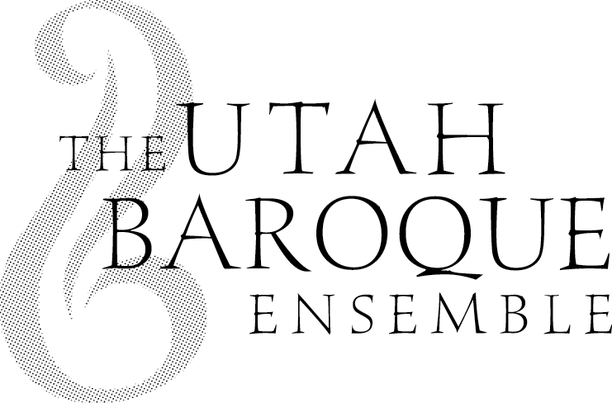
2024
Student Scholarship Competition
& Master Class

Sponsored by the Utah Baroque Ensemble

Open to all Utah County music students in grades 9-12.

Competition: The Competition is open to both vocal and instrumental artists from Utah County (or who are students of a music teacher living in Utah County) performing a Baroque period piece. Audition recordings in video format may be submitted online from February 5 through February 21, 2024. ($20 application fee) Finalists will be chosen based on these audition recordings.

Finalists will perform their Baroque piece in an adjudicated recital at the Orem Public Library on Monday evening, March 18, 2024. One finalist will be awarded a $500 scholarship and will perform at the Utah Baroque Ensemble concert in Orem on Sunday evening April 14, 2024. Other performance opportunities may be available, and several other smaller scholarships will be awarded.

Elementary and junior high students are encouraged to apply by the same method and perform at the March 18 recital non-competitively.

Master Class: Students are strongly encouraged to register for a Baroque Master Class to help prepare for the Competition. The class will be taught by Alex Woods (BYU professor of violin, chamber music, and director of the BYU Baroque Ensemble) on Monday, February 5, 2024, 3:30-6:00 p.m. at the Piano Gallery Recital Hall in Orem. NOTE: Registration for the Class ($20) also covers the entry fee for the Competition.

Questions? Email Janet Bradford at ube.competition@gmail.com
Please go to www.utahbaroque.org for more detailed up-to-date information.

